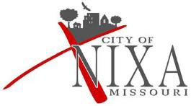
NIXA CITY COUNCIL
SPECIAL MEETING
Tentative Agenda
June 29th, 2022
5:00 PM
NIXA CITY HALL
715 W. MT. VERNON

This meeting will be conducted at 715 W. Mt. Vernon. Individuals may view the meeting live on our YouTube channel: https://www.youtube.com/c/CityofNixa

Call to Order
Roll Call
Pledge of Allegiance

Ordinances (Second Reading and Public Hearing; Comments Limited to 5 Minutes; Council Vote Anticipated):
Council Bill #2022-065 Amending Section 16-200 of the Nixa City Code to Authorize the Discharge of Fireworks Within the City Limits for July 2nd and 3rd, 2022

Adjournment

Council/ Staff Liaisons
Jarad Giddens/Doug Colvin-Public Works Darlene Graham/Joe Campbell-Police
Amy Hoogstraet/Matt Crouse-Park Aron Peterson/ -Planning/Development
Shawn Lucas/Jennifer Evans-Finance & Amanda Hunsucker-Human Resources
Justin Orf/Cindy Robbins-Administration/Court & Drew Douglas-Communications

